Assignment 9

-- Drop all tables

DROP TABLE users CASCADE CONSTRAINTS;

DROP TABLE admins CASCADE CONSTRAINTS;

DROP TABLE items CASCADE CONSTRAINTS;

DROP TABLE itemPricing CASCADE CONSTRAINTS;

DROP TABLE itemDates CASCADE CONSTRAINTS;

DROP TABLE auctions CASCADE CONSTRAINTS;

DROP TABLE auctionStatus CASCADE CONSTRAINTS;

DROP TABLE financeUser CASCADE CONSTRAINTS;

DROP TABLE financeDetails CASCADE CONSTRAINTS;

DROP TABLE shippingUser CASCADE CONSTRAINTS;

DROP TABLE shippingDetails CASCADE CONSTRAINTS;

DROP TABLE bidDetails CASCADE CONSTRAINTS;

DROP TABLE bidStatus CASCADE CONSTRAINTS;

DROP TABLE pastBidDetails CASCADE CONSTRAINTS;

DROP TABLE pastBidStatus CASCADE CONSTRAINTS;

-- Create users table

CREATE TABLE users (

user_id INTEGER NOT NULL,

user_name VARCHAR2(30) NOT NULL,

user_username VARCHAR2(30) NOT NULL UNIQUE,

user_password VARCHAR2(30) NOT NULL,

PRIMARY KEY(user_id)

);

-- Create admins table

CREATE TABLE admins (

admin_id INTEGER NOT NULL,

admin_username VARCHAR2(30) NOT NULL UNIQUE,

admin_password VARCHAR2(30) NOT NULL,

PRIMARY KEY(admin_id)

);

-- Create items table

CREATE TABLE items (

item_id INTEGER NOT NULL,

item_name VARCHAR2(30) NOT NULL,

item_description VARCHAR2(100) NOT NULL,

PRIMARY KEY(item_id)

);

-- Create itemPricing table

CREATE TABLE itemPricing (

item_id INTEGER REFERENCES items(item_id),

item_minBid DECIMAL (10, 2) DEFAULT 0.00 NOT NULL,

item_buyPrice DECIMAL(10, 2),

PRIMARY KEY(item_id, item_minBid),

CHECK (item_buyPrice > item_minBid)

);

-- Create itemDates table

CREATE TABLE itemDates (

-- DATE format: YYYY-MM-DD

item_id INTEGER REFERENCES items(item_id),

item_startDate DATE NOT NULL,

item_endDate DATE NOT NULL,

PRIMARY KEY(item_id, item_startDate),

CHECK (item_startDate <= item_endDate)

);

-- Create auctions table

CREATE TABLE auctions (

auction_id INTEGER NOT NULL UNIQUE,

user_id INTEGER REFERENCES users(user_id) NOT NULL,

item_id INTEGER REFERENCES items(item_id) NOT NULL,

PRIMARY KEY(user_id, item_id)

);

-- Create auctionStatus table

CREATE TABLE auctionsStatus (

auction_id INTEGER REFERENCES auctions(auction_id),

auction_latest DATE NOT NULL,

PRIMARY KEY(auction_id)

);

-- Create financeUser table

CREATE TABLE financeUser (

user_id INTEGER REFERENCES users(user_id),

finance_number NUMBER(16) NOT NULL UNIQUE,

PRIMARY KEY(user_id)

);

-- Create financeDetails table

CREATE TABLE financeDetails (

finance_number NUMBER(16) REFERENCES financeUser(finance_number),

finance_expiry DATE NOT NULL,

finance_address VARCHAR2(30) NOT NULL,

finance_cvv INTEGER NOT NULL,

PRIMARY KEY(finance_number)

);

-- Create shippingUser table

CREATE TABLE shippingUser (

user_id INTEGER REFERENCES users(user_id),

shipping_tracking VARCHAR2(50) NOT NULL UNIQUE,

PRIMARY KEY(user_id)

);

-- Create shippingDetails table

CREATE TABLE shippingDetails (

shipping_tracking VARCHAR2(50) REFERENCES shippingUser(shipping_tracking),

shipping_receiver VARCHAR2(200) NOT NULL,

PRIMARY KEY(shipping_tracking)

);

-- Create bidDetails table

CREATE TABLE bidDetails (

item_id INTEGER REFERENCES items(item_id),

user_id INTEGER REFERENCES users(user_id),

bids_id INTEGER NOT NULL UNIQUE,

PRIMARY KEY(item_id, user_id)

);

-- Create bidStatus table

CREATE TABLE bidStatus (

bids_id INTEGER REFERENCES bidDetails(bids_id),

bids_top DECIMAL(10, 2) NOT NULL,

PRIMARY KEY(bids_id)

);

-- Create pastBidDetails table

CREATE TABLE pastBidDetails (

item_id INTEGER REFERENCES items(item_id),

user_id INTEGER REFERENCES users(user_id),

pastbids_id INTEGER NOT NULL UNIQUE,

PRIMARY KEY(item_id, user_id)

);

-- Create pastBidStatus table

CREATE TABLE pastBidStatus (

pastbids_id INTEGER REFERENCES pastBidDetails(pastbids_id),

pastbid_bidDate DATE NOT NULL,

pastbid_bid DECIMAL(10, 2) NOT NULL,

PRIMARY KEY(pastbids_id)

);

**-- INSERT STATEMENTS**

-- Insert data into users table

INSERT INTO users(user_id, user_name, user_username, user_password) VALUES (1, 'Zoravar Multani', 'gogurtlover15', 'ilovegogurt');

INSERT INTO users(user_id, user_name, user_username, user_password) VALUES (2, 'Justin Lee', 'zesuckermol3r4t', 'iglazezora');

INSERT INTO users(user_id, user_name, user_username, user_password) VALUES (3, 'Karen Loac', 'hater146', 'ihatejeffery');

INSERT INTO users(user_id, user_name, user_username, user_password) VALUES (4, 'Jefferey Wong', 'pumpkineater', 'pantsonfire');

INSERT INTO users(user_id, user_name, user_username, user_password) VALUES (5, 'Joaquin Kataoka', 'jhunglover', 'igrewmybeard');

INSERT INTO users(user_id, user_name, user_username, user_password) VALUES (6, 'Justin Hung', 'keijilover', 'ipermmyhair');

-- Insert data into admins table

INSERT INTO admins(admin_id, admin_username, admin_password) VALUES (1, 'admin1', 'adminpassword1');

INSERT INTO admins(admin_id, admin_username, admin_password) VALUES (2, 'admin2', 'adminpassword2');

INSERT INTO admins(admin_id, admin_username, admin_password) VALUES (3, 'admin3', 'adminpassword2');

INSERT INTO admins(admin_id, admin_username, admin_password) VALUES (4, 'admin4', 'adminpassword2');

INSERT INTO admins(admin_id, admin_username, admin_password) VALUES (5, 'admin5', 'adminpassword2');

-- Insert data into items table

INSERT INTO items(item_id, item_name, item_description) VALUES (1, 'Item 1','Description for Item 1');

INSERT INTO items(item_id, item_name, item_description) VALUES (2, 'Item 2', 'Description for Item 2');

INSERT INTO items(item_id, item_name, item_description) VALUES (3, 'Item 3', 'Description for Item 3');

INSERT INTO items(item_id, item_name, item_description) VALUES (4, 'Item 4', 'Description for Item 4');

INSERT INTO items(item_id, item_name, item_description) VALUES (5, 'Item 5', 'Description for Item 5');

-- Insert data into itemPricing table

INSERT INTO itemPricing(item_id, item_minBid, item_buyPrice) VALUES (1, 10.00, 20.00);

INSERT INTO itemPricing(item_id, item_minBid, item_buyPrice) VALUES (2, 15.00, 30.00);

INSERT INTO itemPricing(item_id, item_minBid, item_buyPrice) VALUES (3, 10.00, 30.00);

INSERT INTO itemPricing(item_id, item_minBid, item_buyPrice) VALUES (4, 15.00, 35.00);

INSERT INTO itemPricing(item_id, item_minBid, item_buyPrice) VALUES (5, 20.00, 40.00);

-- Insert data into itemDates table

INSERT INTO itemDates(item_id, item_startDate, item_endDate) VALUES (1, '2023-11-01', '2023-11-10');

INSERT INTO itemDates(item_id, item_startDate, item_endDate) VALUES (2, '2023-11-05', '2023-11-15');

INSERT INTO itemDates(item_id, item_startDate, item_endDate) VALUES (3, '2023-12-01', '2023-12-10');

INSERT INTO itemDates(item_id, item_startDate, item_endDate) VALUES (4, '2023-12-05', '2023-12-15');

INSERT INTO itemDates(item_id, item_startDate, item_endDate) VALUES (5, '2023-12-10', '2023-12-20');

-- Insert data into auctions table

INSERT INTO auctions(auction_id, user_id, item_id) VALUES (1, 1, 1);

INSERT INTO auctions(auction_id, user_id, item_id) VALUES (2, 2, 2);

INSERT INTO auctions(auction_id, user_id, item_id) VALUES (3, 3, 3);

INSERT INTO auctions(auction_id, user_id, item_id) VALUES (4, 4, 4);

INSERT INTO auctions(auction_id, user_id, item_id) VALUES (5, 5, 5);

-- Insert data into auctionStatus table

INSERT INTO auctionStatus(auction_id, auction_latest) VALUES (1, '2023-11-08');

INSERT INTO auctionStatus(auction_id, auction_latest) VALUES (2, '2023-11-12');

INSERT INTO auctionStatus(auction_id, auction_latest) VALUES (3, '2023-12-08');

INSERT INTO auctionStatus(auction_id, auction_latest) VALUES (4, '2023-12-12');

INSERT INTO auctionStatus(auction_id, auction_latest) VALUES (5, '2023-12-16');

-- Insert data into financeUser table

INSERT INTO financeUser(user_id, finance_number) VALUES (1, 1234567890123456);

INSERT INTO financeUser(user_id, finance_number) VALUES (2, 9876543210987654);

INSERT INTO financeUser(user_id, finance_number) VALUES (3, 1111222233334444);

INSERT INTO financeUser(user_id, finance_number) VALUES (4, 5555666677778888);

INSERT INTO financeUser(user_id, finance_number) VALUES (5, 9999888877775555);

-- Insert data into financeDetails table

INSERT INTO financeDetails(finance_number, finance_expiry, finance_address, finance_cvv) VALUES (1234567890123456, '2024-12-31', '1735 Danforth Ave', 123);

INSERT INTO financeDetails(finance_number, finance_expiry, finance_address, finance_cvv) VALUES (9876543210987654, '2025-06-30', '123 Yonge St', 456);

INSERT INTO financeDetails(finance_number, finance_expiry, finance_address, finance_cvv) VALUES (1111222233334444, '2024-12-31', '710 King St W', 456);

INSERT INTO financeDetails(finance_number, finance_expiry, finance_address, finance_cvv) VALUES (5555666677778888, '2025-06-30', '344 Bathurst St', 789);

INSERT INTO financeDetails(finance_number, finance_expiry, finance_address, finance_cvv) VALUES (9999888877775555, '2026-01-15', '552 Yonge St', 123);

-- Insert data into shippingUser table

INSERT INTO shippingUser(user_id, shipping_tracking) VALUES (1, 'SHIPPING123');

INSERT INTO shippingUser(user_id, shipping_tracking) VALUES (2, 'SHIPPING456');

INSERT INTO shippingUser(user_id, shipping_tracking) VALUES (3, 'SHIPPING789');

INSERT INTO shippingUser(user_id, shipping_tracking) VALUES (4, 'SHIPPING101');

INSERT INTO shippingUser(user_id, shipping_tracking) VALUES (5, 'SHIPPING1234');

-- Insert data into shippingDetails table

INSERT INTO shippingDetails(shipping_tracking, shipping_receiver) VALUES ('SHIPPING123', 'John Doe');

INSERT INTO shippingDetails(shipping_tracking, shipping_receiver) VALUES ('SHIPPING456', 'Jane Smith');

INSERT INTO shippingDetails(shipping_tracking, shipping_receiver) VALUES ('SHIPPING789', 'Alice Johnson');

INSERT INTO shippingDetails(shipping_tracking, shipping_receiver) VALUES ('SHIPPING101', 'Bob Smith');

INSERT INTO shippingDetails(shipping_tracking, shipping_receiver) VALUES ('SHIPPING1234', 'Eve Adams');

-- Insert data into bidDetails table

INSERT INTO bidDetails(item_id, user_id, bids_id) VALUES (1, 1, 1);

INSERT INTO bidDetails(item_id, user_id, bids_id) VALUES (2, 2, 2);

INSERT INTO bidDetails(item_id, user_id, bids_id) VALUES (3, 3, 6);

INSERT INTO bidDetails(item_id, user_id, bids_id) VALUES (4, 4, 7);

INSERT INTO bidDetails(item_id, user_id, bids_id) VALUES (5, 5, 8);

-- Insert data into bidStatus table

INSERT INTO bidStatus(bids_id, bids_top) VALUES (1, 30.00);

INSERT INTO bidStatus(bids_id, bids_top) VALUES (2, 40.00);

INSERT INTO bidStatus(bids_id, bids_top) VALUES (6, 50.00);

INSERT INTO bidStatus(bids_id, bids_top) VALUES (7, 60.00);

INSERT INTO bidStatus(bids_id, bids_top) VALUES (8, 70.00);

-- Insert data into pastBidDetails table

INSERT INTO pastBidDetails(item_id, user_id, pastbids_id) VALUES (1, 1, 1);

INSERT INTO pastBidDetails(item_id, user_id, pastbids_id) VALUES (2, 2, 2);

INSERT INTO pastBidDetails(item_id, user_id, pastbids_id) VALUES (3, 3, 6);

INSERT INTO pastBidDetails(item_id, user_id, pastbids_id) VALUES (4, 4, 7);

INSERT INTO pastBidDetails(item_id, user_id, pastbids_id) VALUES (5, 5, 8);

-- Insert data into pastBidStatus table

INSERT INTO pastBidStatus(pastbids_id, pastbid_bidDate, pastbid_bid) VALUES (1, '2023-11-08', 25.00);

INSERT INTO pastBidStatus(pastbids_id, pastbid_bidDate, pastbid_bid) VALUES (2, '2023-11-10', 35.00);

INSERT INTO pastBidStatus(pastbids_id, pastbid_bidDate, pastbid_bid) VALUES (6, '2023-12-05', 45.00);

INSERT INTO pastBidStatus(pastbids_id, pastbid_bidDate,en pastbid_bid) VALUES (7, '2023-12-10', 55.00);

INSERT INTO pastBidStatus(pastbids_id, pastbid_bidDate, pastbid_bid) VALUES (8, '2023-12-15', 65.00);

SELECT * FROM users;

SELECT * FROM admins;

SELECT * FROM items;

SELECT * FROM itemPricing;

SELECT * FROM itemDates;

SELECT * FROM auctions;

SELECT * FROM auctionStatus;

SELECT * FROM financeUser;

SELECT * FROM financeDetails;

SELECT * FROM shippingUser;

SELECT * FROM shippingDetails;

SELECT * FROM bidDetails;

SELECT * FROM bidStatus;

SELECT * FROM pastBidDetails;

SELECT * FROM pastBidStatus;

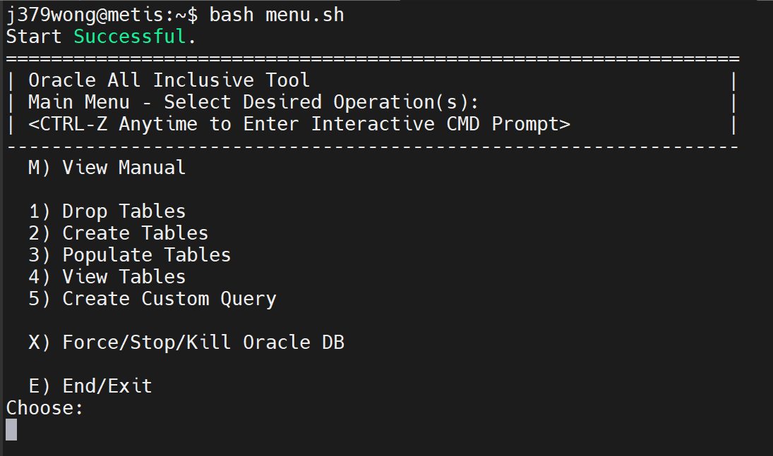

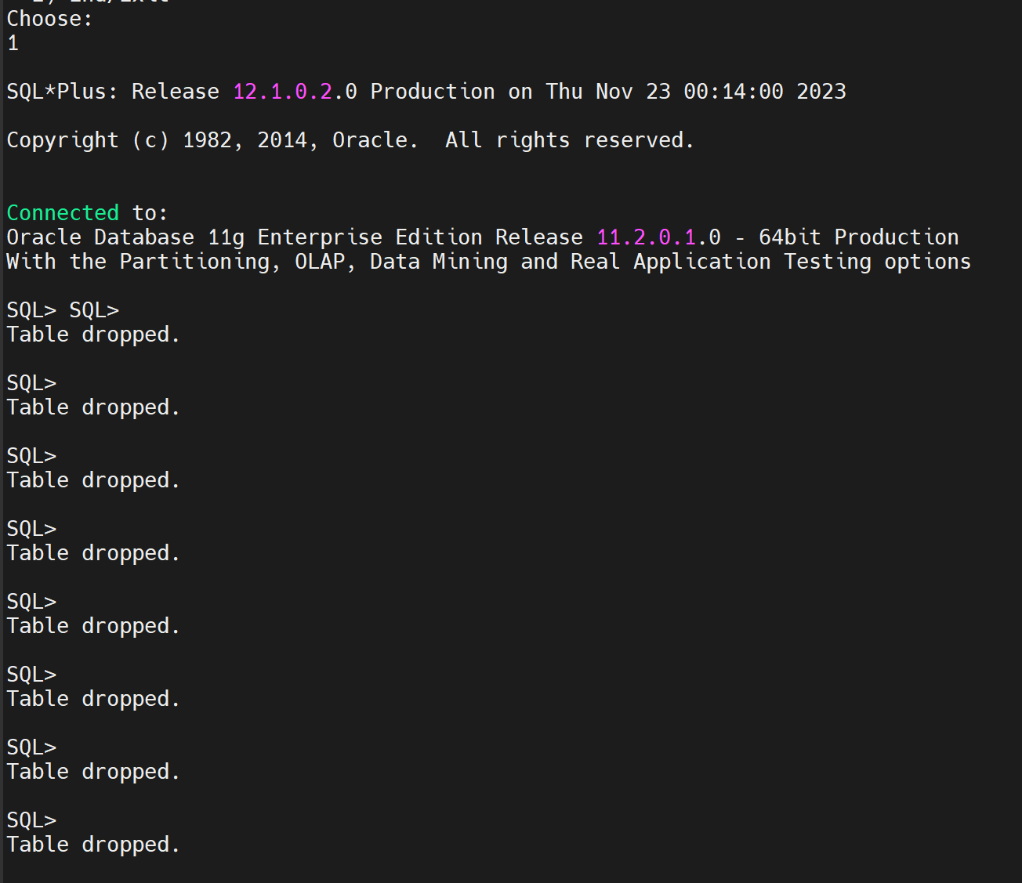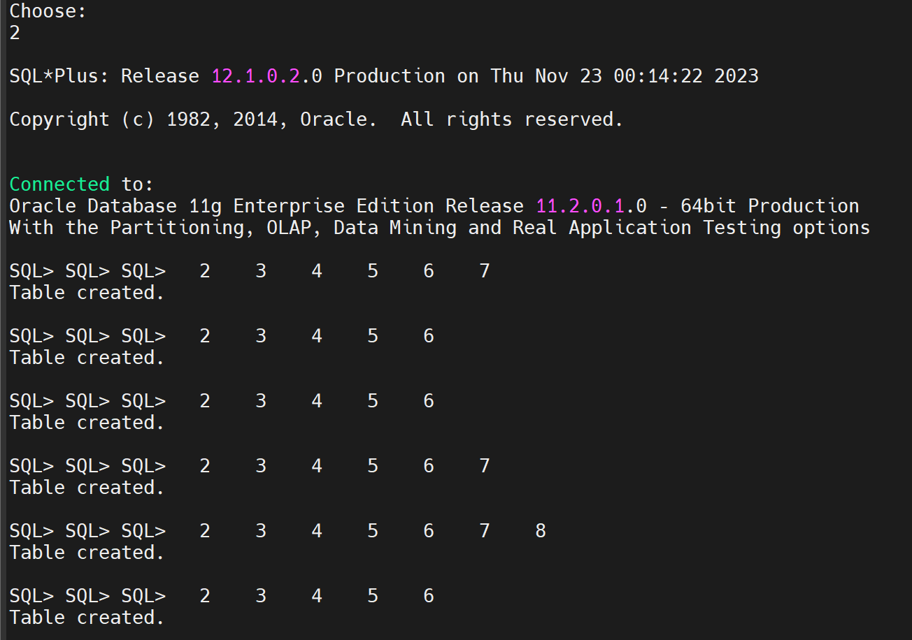

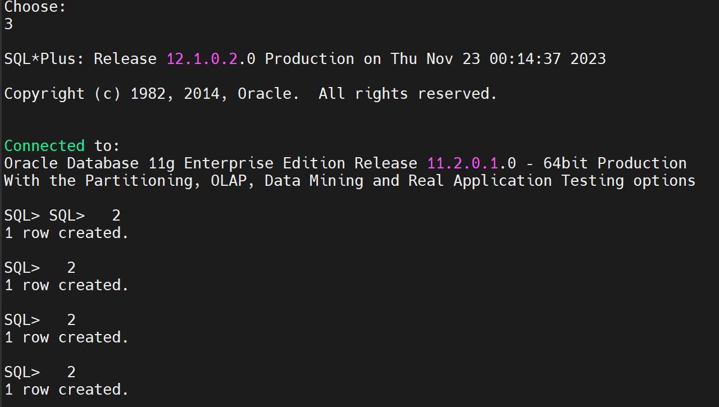

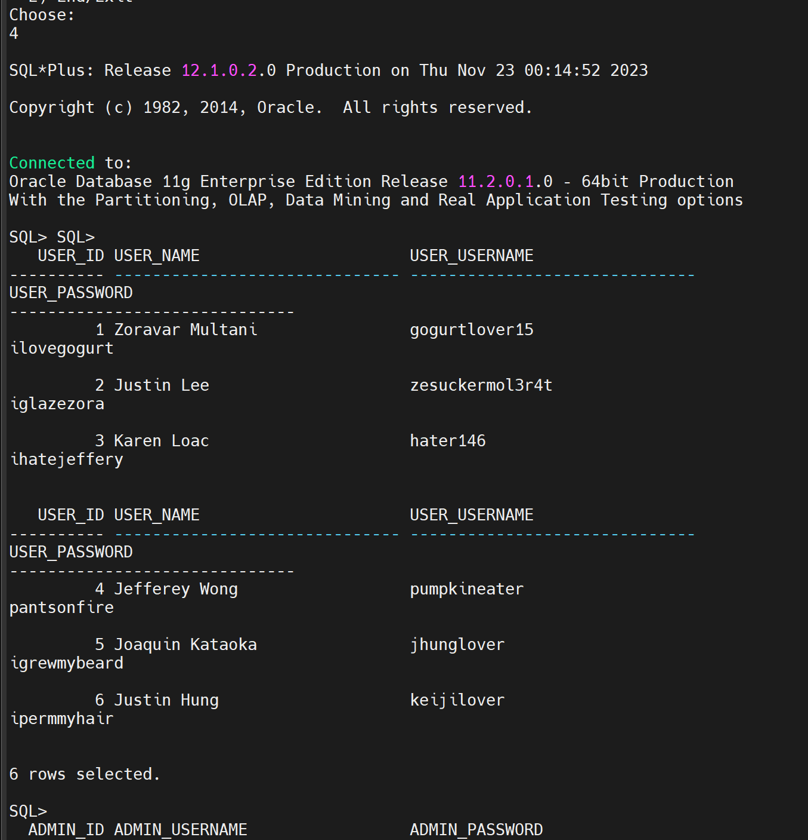

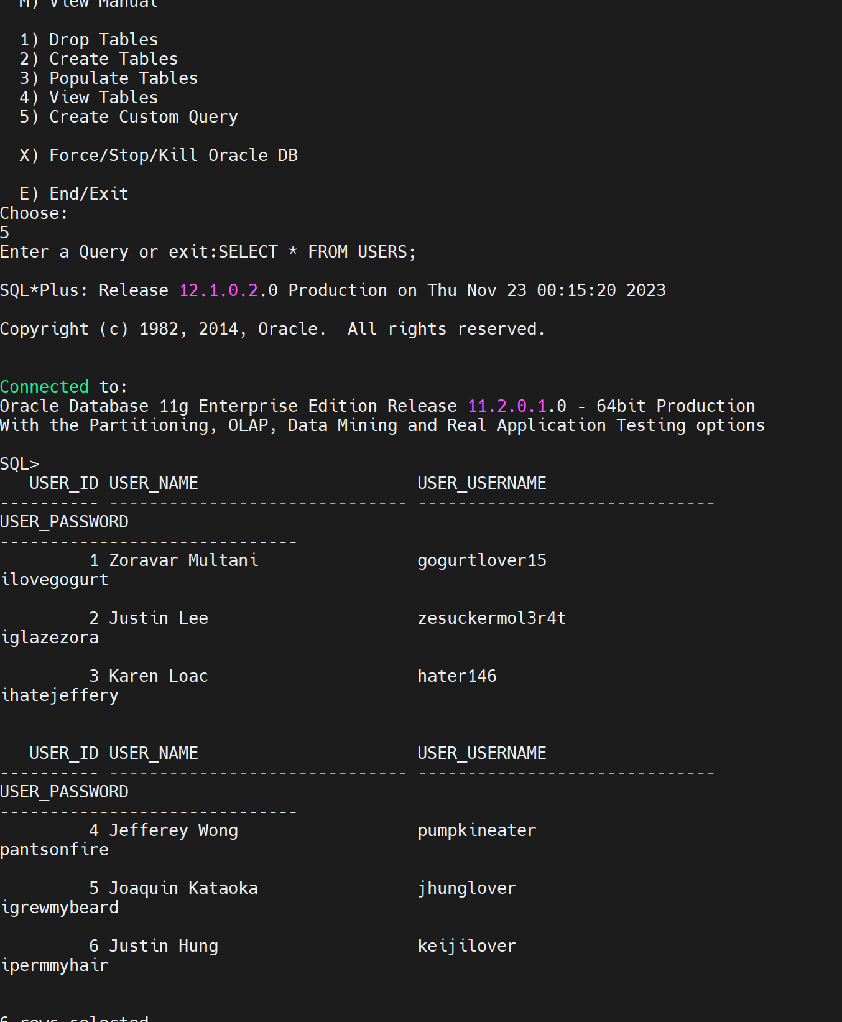

Java swing GUI will be made for next weeks demo